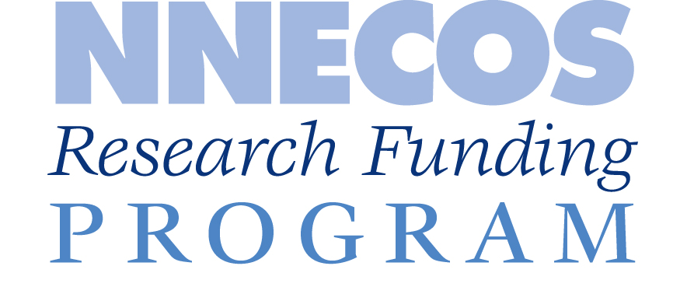
Call for Proposals
The Northern New England Clinical Oncology Society is seeking research funding proposals for investigative projects of value to the entire Northern New England community of cancer care providers. The society seeks to award one or more research grants to worthy proposals, up to a total of $20,000. Eligible candidates will be a current NNECOS member in good standing. Projects should be in alignment with the society’s mission to promote the highest quality care for patients with cancer and blood disorders in our region. Preference will be given to projects promoting collaboration amongst NNECOS institutions (academic and community). Fellows and others are strongly encouraged to apply.
Proposal Elements
Proposals should satisfy the following criteria:
- Introduction: Describes the problem and data supporting development of the research question. The introduction should be limited to 1-2 paragraphs.
- Objectives: Propose clearly defined objectives and describe what specific measures will be used to determine if objective is satisfied. There should be a limited number of objectives with one primary objective.
- Methods
- Statistics: Except for small pilot/feasibility studies, statistics should be provided to support sample sizes.
- Budget: The budget must be clearly outlined. Indirect costs and salary support for academic attending physicians and private practice providers should not be included in a budget. Materials and funds for services of collaborating facility employees required in the operations of a project (i.e. research coordinator, statistician, etc. in alignment with national averages for their role) are examples of items to include in the budget. If the proposal is part of a larger project, the total amount of funding and its sources should be disclosed.
- References: Pertinent journal and abstract references to support proposal should be provided.
- Total Length: The introduction, objectives, methods and statistics sections should cover no more than 2 pages in length.
Notification
Awardees will be notified in approximately 30 days, be required to submit progress reports to NNECOS, and may be asked to present a final report of the research to the NNECOS annual meeting.

Northern New England Clinical Oncology Society Collaborative Research Funding Proposal
Submission Deadline Extended: email to info@nnecos.org no later January 31, 2021.

Collaborators & Institution/Practice Affiliation:

Project Title:

Total Length: The introduction, objectives, methods and statistics sections should cover no more than 2 pages in length.

Introduction: Describe the problem and data supporting development of the research question. The introduction should be limited to 1-2 paragraphs.

Objectives: Propose clearly defined objectives and describe what specific measures will be used to determine if objective is satisfied. There should be a limited number of objectives with one primary objective.

Methods:

Statistics: Except for small pilot/feasibility studies, statistics should be provided to support sample sizes.

Budget: The budget must be clearly outlined. Indirect costs and salary support for academic attending physicians and private practice providers should not be included in a budget. Materials and funds for services of collaborating facility employees required in the operations of a project (i.e. research coordinator, statistician, etc. in alignment with national averages for their role) are examples of items to include in the budget. If the proposal is part of a larger project, the total amount of funding and its sources should be disclosed.

References: Pertinent journal and abstract references to support proposal should be provided.

